How to Register for a New e-Clearinghouse Account

Thank you for your interest in submitting a project in our e-Clearinghouse portal to satisfy the mandatory intergovernmental review of federal programs in accordance with Presidential Executive Order 12372(enacted July 14, 1982). To register for an account, please visit: www.dlgportal.ky.gov. Click the Register/Login tab shown below.

Once your profile is set up, then you can begin to submit your project through the e-Clearinghouse portal. If you would like tutorials for submitting a project or registering for an account, please visit here:

https://dlg.ky.gov/Pages/kentucky-eclearinghouse.aspx

or https://www.dlgportal.ky.gov/en-US/

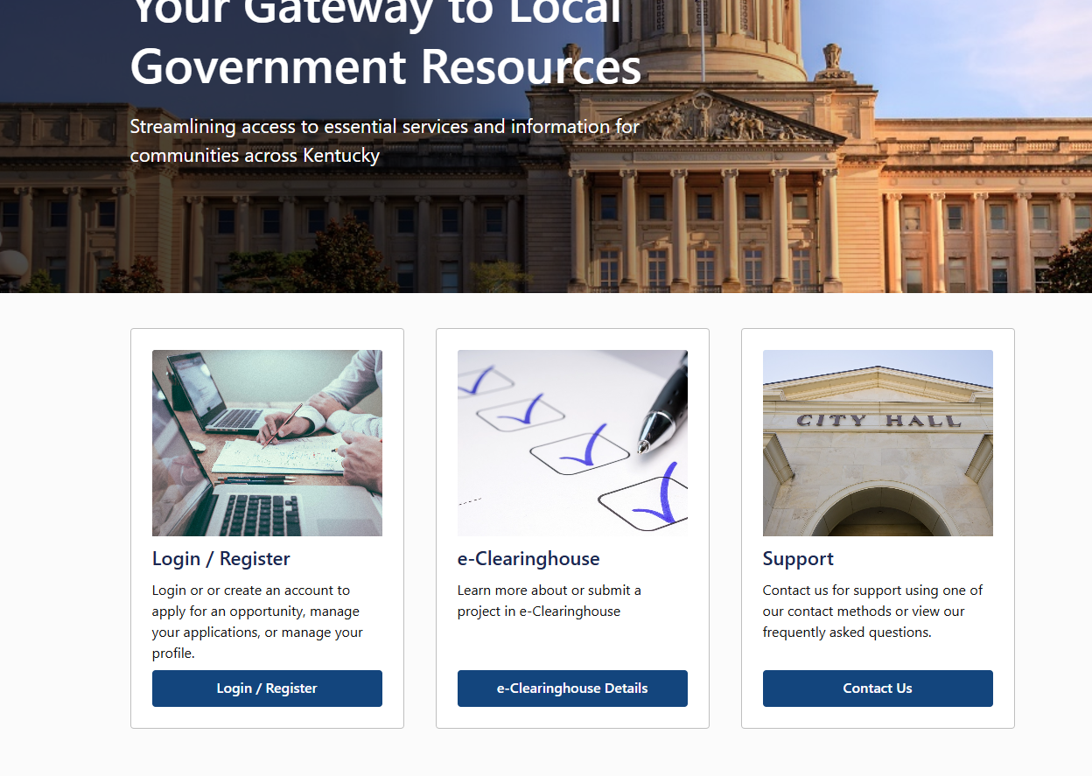

If you have any questions or concerns along the way, please feel free to contact me as I am always willing to assist as needed.

Kindly,

Cindy Seip
Cindy Seip, Program Coordinator/SPOC
Kentucky e-Clearinghouse
Department for Local Government
100 Airport Road
Third Floor
Frankfort, KY 40601
(502) 892-4149
"If I cannot do great things, I can do small things in a great way."
Dr. Martin Luther King, Jr.

